HW6

Jingyu Li

Question 1:

Epoch 0

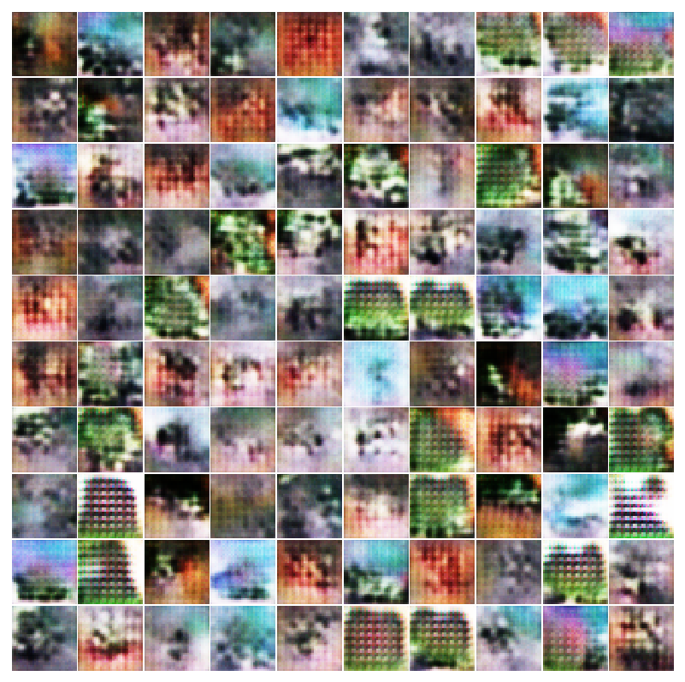

Epoch 19

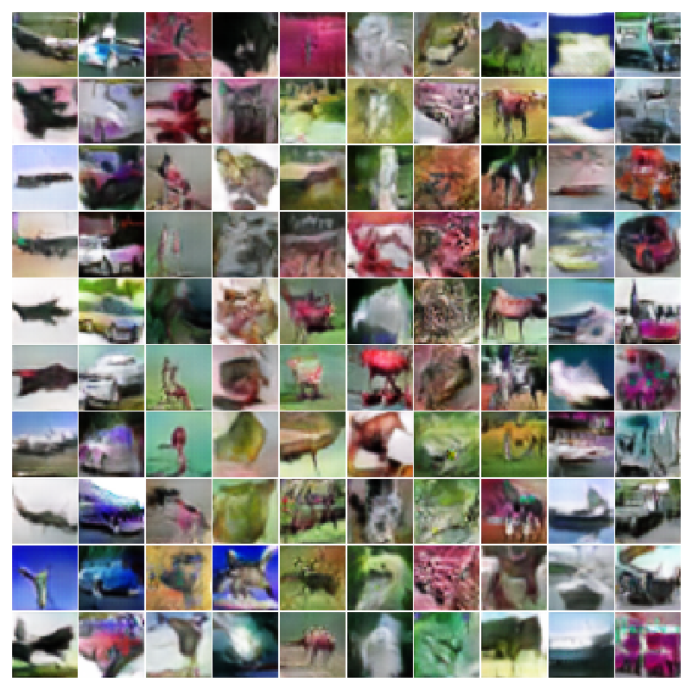

Epoch 59

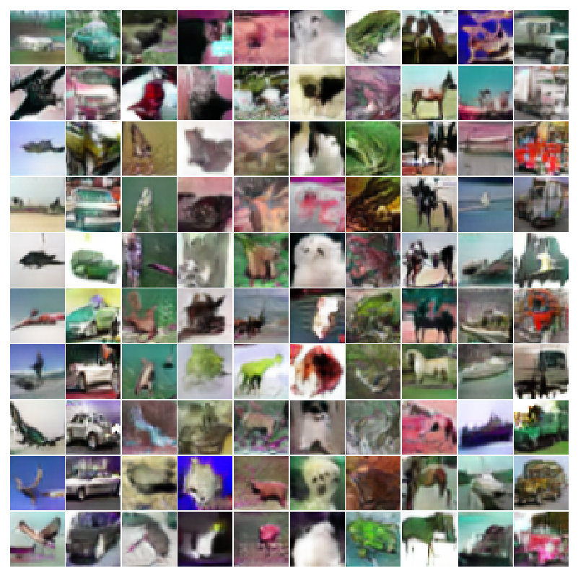

Epoch 99

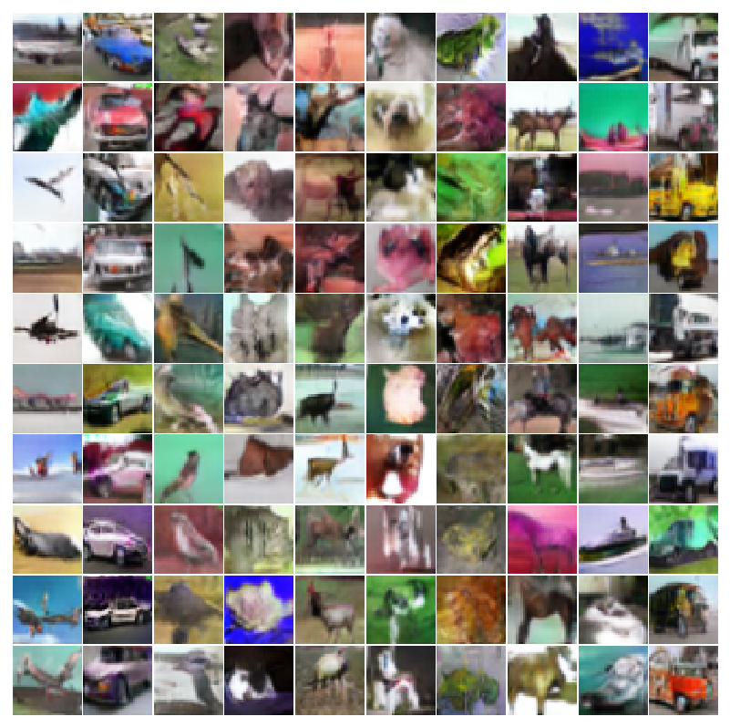

Epoch 149

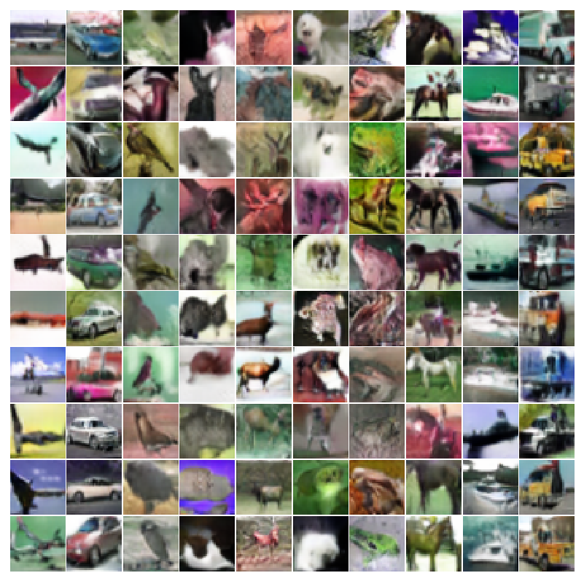

Epoch 199

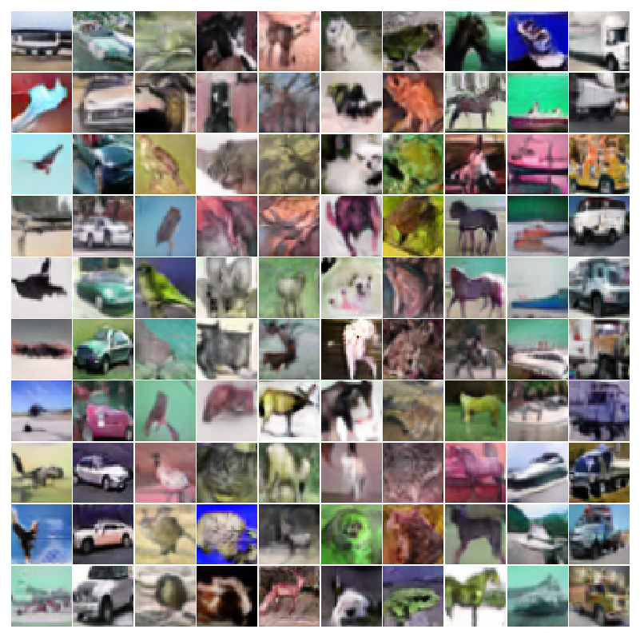

Question 2:

Real Images

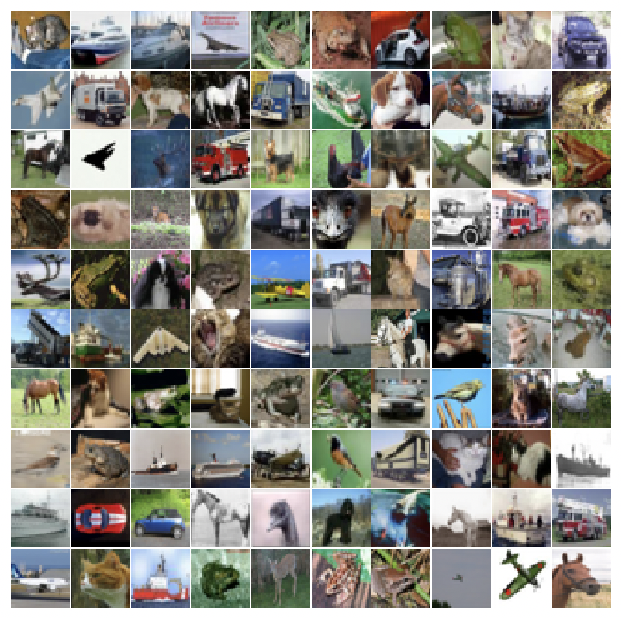

Gradients from an alternate class for these images

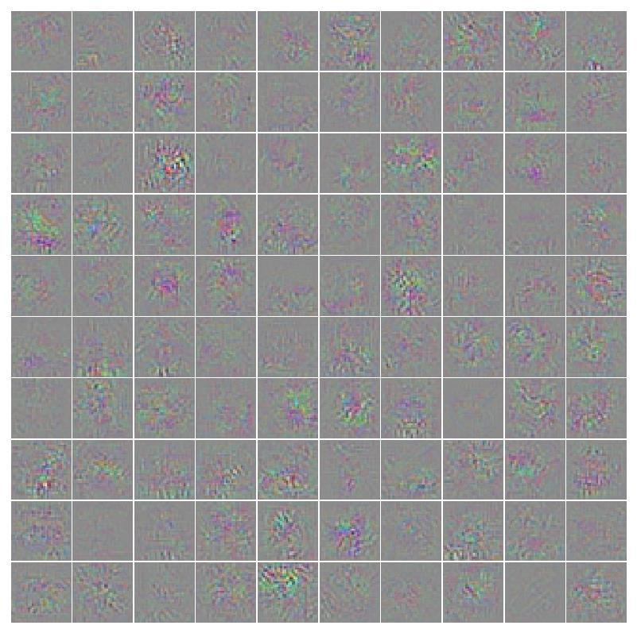

Modified images

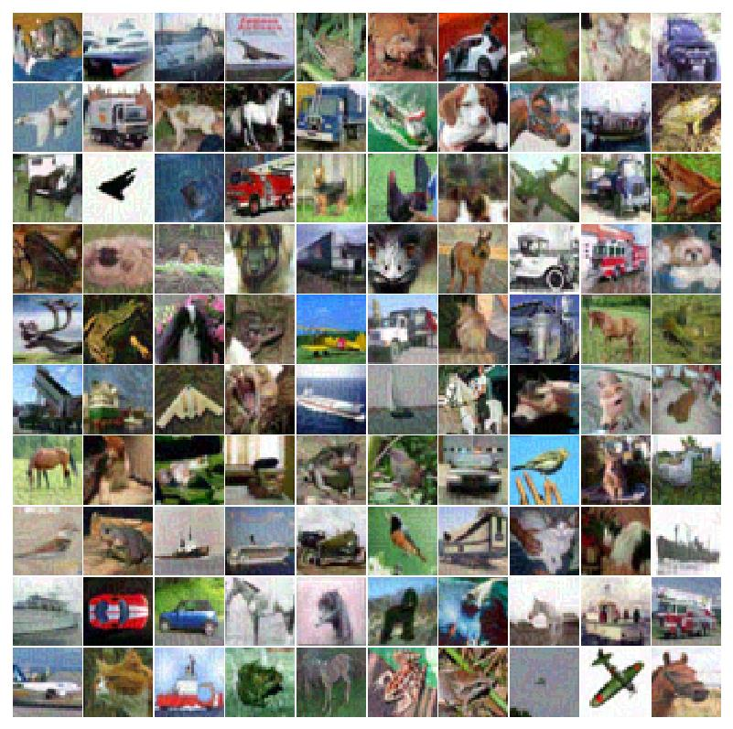

Question 3:

Synthetic images maximizing the class output

For discriminator trained without the generator:

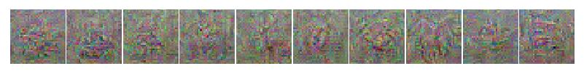

for discriminator trained with generator

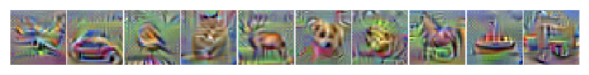

Question 4:

Synthetic images maximizing a particular layer of features

For discriminator trained without the generator

Synthetic images maximizing layer 4 of features

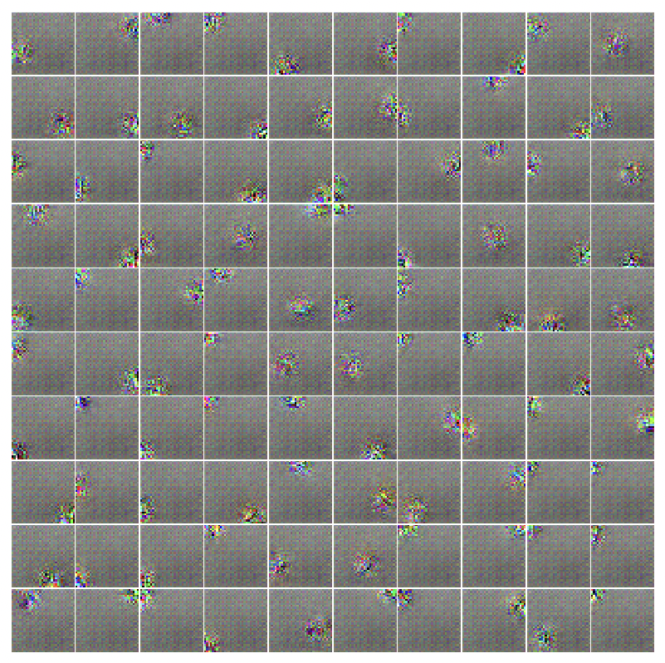

Synthetic images maximizing layer 8 of features

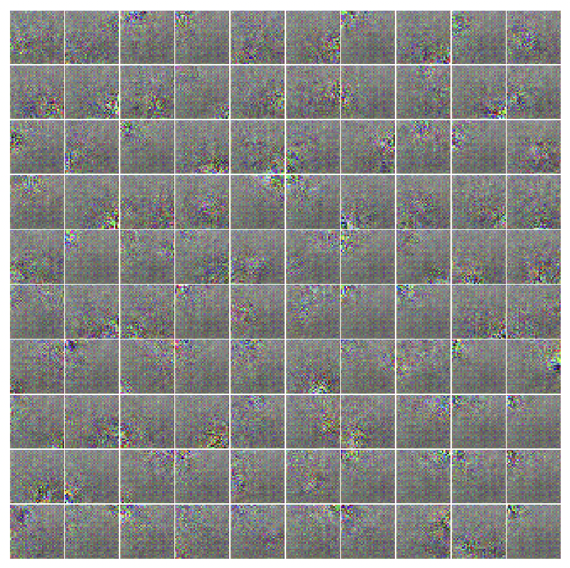

For discriminator trained with the generator

Synthetic images maximizing layer 4 of features

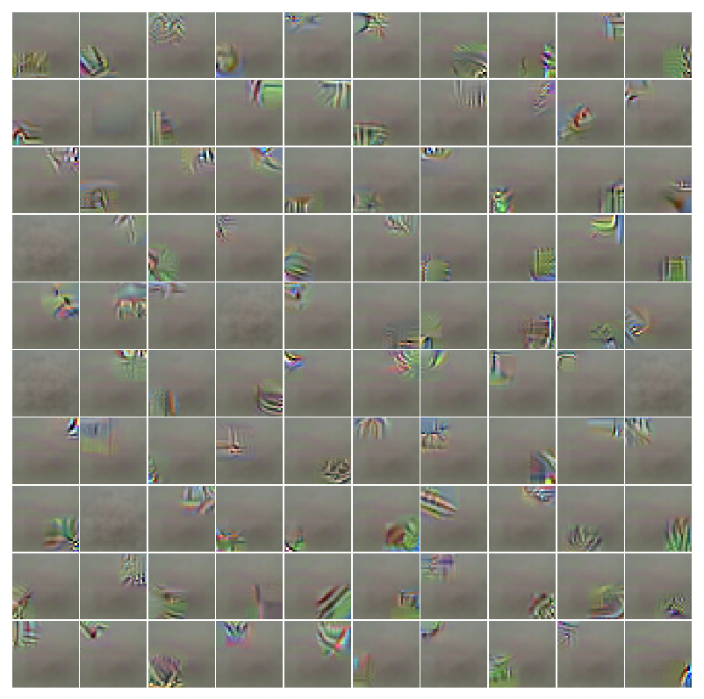

Synthetic images maximizing layer 8 of features

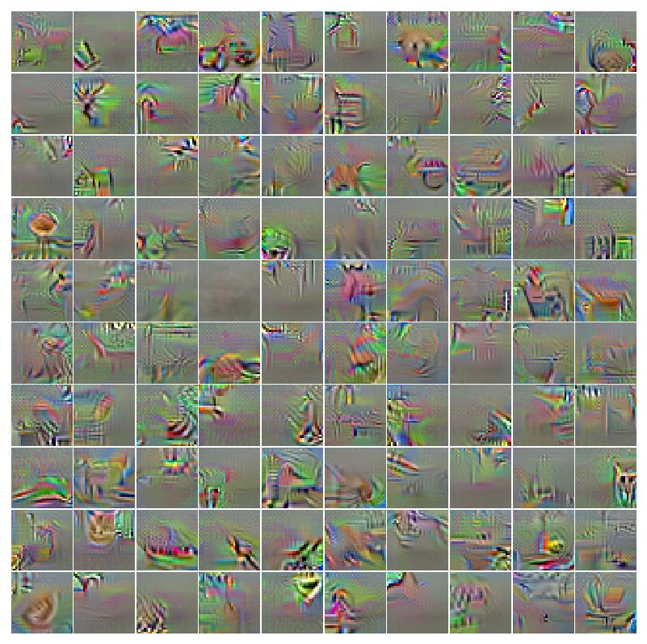

Question 5:

Test accuracy for discriminator trained without generator = 89.09%

Test accuracy for discriminator trained with generator = 83.47%